Mr Chairman and members of Cappoquin Community Development Company CLG;
I present hereunder the annual report of the Company for the calendar year 2016. The Company is now in existence for 23 years and this is its 22nd annual report.
The Company, over that past 23 years, has provided many community services and facilities for the people of the area and has contributed significantly to the economic progression of the town. The Company, in addition, continues to enhance its reputation with the general public and with government agencies and is very often put forward as an example of a successful community organisation.
Throughout the year the Company provided an extensive childcare service, education and training services in conjunction with the Waterford Wexford Educational and Training Board (WWETB), facilities for leisure and fitness pursuits, a venue for performing artists, a location for general activities for young and old and commercial units for start up businesses and small company operations. The Community Centre continues to be the focal point in Cappoquin for social and leisure interests and is thus a major economic benefit to the town.
2016 was a year in which difficult decisions had to be made in relation to the future operation of the Company. Early in the year the Company discontinued its contract with the manager and alternative arrangements had to be put in place with the respective committees taking more active roles in the management of their individual areas. This continued throughout the year with some administrative assistance also being provided. The dependence on the committee structure was most successful as the members committed themselves fully to the tasks involved.
2016 was thus a period of transition and transformation for the Company. Procedures were put in place for the short term management and financial stability of the organisation. A significant emphasis was placed on the operation of the Childcare facility with particular attention to its income and expenditure.
The Company prepared two significant reports during the year relating to the Childcare Facility and the Company Management Structure. These reports recommended proposals for the future operation of the childcare and the Company. Both these are subject to a midterm review in 2017.
Previous reports have mentioned the dedication and commitment of members and this was clearly again evident throughout 2016 particularly by the manner in which management was carried out. This ensured the continuity of the organisation and the provision of vital services to the community. Again it must be stressed that this commitment is completely on a voluntary basis.
It is with a sense of sadness that we record the death during the year of Sr de Lourdes one of our esteemed Company members. Sr de Lourdes, in addition to being a Company member since 1998, served the town of Cappoquin for many years in the field of education with the Sisters of Mercy and as a tireless community worker. Sr de Lourdes assisted many individuals and families in the area through her caring attitude and great interest in the well being of all individuals. We extend our sympathy to Sr de Lourdes’ family, friends and the Sisters of Mercy congregation.
At the 2016 Annual General Meeting 15 persons were elected to the Governing Body of the Company under the Chairmanship of Dr Ben Murphy. A full list of Governing Body members is given in Appendix A. Ms Grainne O’Connell was elected to the Company during 2016.
A total of 13 meetings of the Governing Body of the Company were held during 2016, minutes of which are available in the Company office. Meetings of Directors and Committees also took place during the year.
During 2016 the Company provided employment for 30 persons in addition to employment provided by WWETB. A list of these Company employees is given in Appendix B.

Community Centre:
Cappoquin Community Centre continued to be a focal point for activities throughout the year. The services provided from the Centre bring many additional people to the town which enhances the expenditure in local businesses. The Community Centre has established itself as being a most successful entity with excellent facilities for the provision of an extensive range of services.
In 2016 the weekly users included Affane Bridge Club, athletics, badminton, GAA hurling and camogie, indoor football, circuit training, Active Retirement Group, Paul Murray Fitness Class, gymnastics and Quidlers Group. One off events included Munster and Waterford Scór na nÓg, Waterford Hospice Dance, Dungarvan Lion’s Club Jigs and Reels, Cappoquin Goes Country, Irish Blood Transfusion, Election Polling Station, First Communion Breakfast, Sean Kelly Tour and Kilfenora Ceili Band.
The Gymnasium continues to be a service which is much in demand. Planning permission was received in 2016 for a 75 sq metre extension and we now await funding being provided for its construction which is estimated at €80,000. The Company acknowledges the assistance of Ms Claire Egan, Mr Conor Prendergast, Mr Paul Murray and Mr Pat Hallissey in providing tuition for gymnasium users.
The Waterford Wexford Educational and Training Board (WWETB) continued to provide adult education and training services as part of its 5 year contract with the Company which began in September 2015. A total of 110 students participated on a weekly basis in the initial year of the service, the vast majority doing accredited courses ranging from Quality and Qualifications Ireland (QQI) Level 2 to QQI Level 5. A complete list of the courses provided is given in Appendix C.

A plaque to remember the Cavanagh family and their contribution to the local community was erected at the main entrance to the Community Centre during the year. The Company thanks Mr Aidan Walsh for the provision of this plaque.

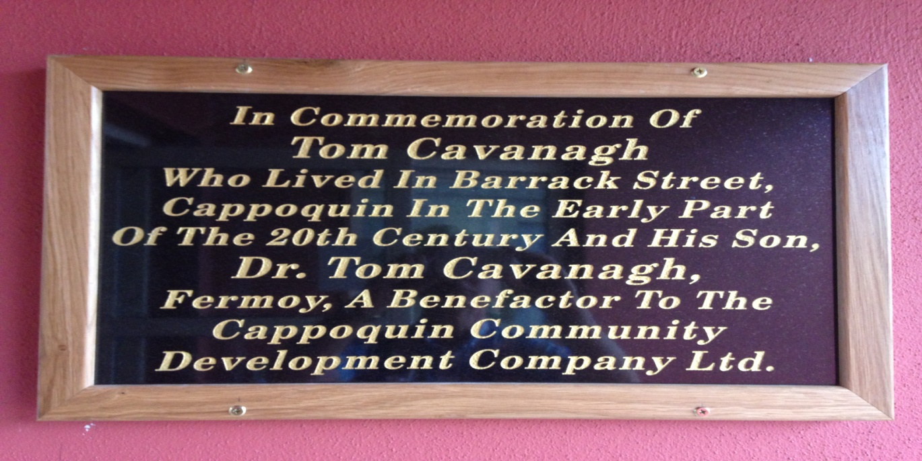

Childcare:
The Childcare Facility celebrated 10 years of existence in 2016. The service provided, continued to be a high quality service and thus very much in demand. The facility provided crèche, toddler, preschool and afterschools service and was availed of by over 100 children each week. As in previous years, independent audits indicated a service operated to the highest standards. This service is highly onerous and carries much responsibility and thus requires constant attention, supervision and management to ensure the provision of a safe and quality service. The Company acknowledges the contribution made by the childcare committee, the manager and staff in maintaining this standard. Supervisory duties were provided by Ms Maria Uniacke, Ms Mairead Landers and Ms Kerry McLaughlin. Food preparation was provided by Ms Josephine Kearns. All staff are garda vetted, fully trained and received up skilling during the year. A list of staff is included in Appendix B.
The financial structures of the childcare facility were examined in July 2016 resulting in some increase in fees being applied for the 2016/17 year. An internal report was prepared in October 2016 which examined the structures within the service and the management of these structures. This report identified the financial risks in operating the service and produced a series of recommendations which are to be implemented to ensure the long term viability of the service. It is now essential that these recommendations are fully enforced. As part of the preparation of this internal report, members of the Company visited childcare facilities in Carrigtwohill and Newcastle.
To comply with legislation Ms Maria Uniacke was appointed Person in Charge in the childcare service with Ms Mairead Landers being appointed Deputy Person in Charge.
Quotations for replacement of the surface of the childcare playground were received and will be submitted when the capital grant scheme is announced in 2017.
The childcare staff and children took part in the local St Patrick’s Day parade and were successful in winning a prize. The Company acknowledges the input of the childcare staff and thank Mr Tom Kiely for provision of transport for the children during the parade.
The continued support of Dr Tom Cavanagh for the afterschools throughout the year is greatly appreciated by the Company. This support ensures that disadvantaged children receive both homework assistance and a daily healthy meal.
The Company also acknowledges and greatly appreciates the extensive support and advice received from the staff of Waterford Co Childcare throughout the year. The support of TUSLA, particularly Ms Monica Ryan is also greatly appreciated.
The support of Pobal in processing subventions is also greatly appreciated.

Enterprise Units:
The conversion of unit 5 to a food preparation standard was completed in early 2016 at a cost of approximately €18,500 for which a grant to the value of €17,867 was received. All 6 enterprise units at the Cappoquin Enterprise Park in the IDA Industrial Estate in Carrigeen were all leased during 2016. Units 3 and 4 were leased to Blackwater Distillers Ltd, unit 5 to the Sausage Experience (Steve O’Flynn), units 6 and 7 to Cappoquin Meats Ltd and unit 8 to the Lismore Biscuit Company. Unfortunately difficulties arose with the tenant of unit 5 and efforts to reach a resolution were unsuccessful and the matter was referred to the Company solicitor.
The Company paid a maintenance fee to the IDA for maintenance of services to this estate. This charge is based on floor area owned by each of the IDA tenants companies.

Finance:
The consolidated accounts of Cappoquin Community Development Company CLG and Cappoquin Community Centre Ltd are attached and will be formally presented for adoption at this AGM. Copies of the Financial Statements for both companies are available in the Company office. While the financial position of the Companies is satisfactory, constant vigilance of these finances is essential. New structures were put in place for financial monitoring with the Finance Committee meeting each month on a fixed date. Extensive financial reports are presented and agreed actions, if necessary, are immediately put in place. Substantial financial risks were identified in the childcare operation particularly in relation to staff rota, collection of fees and day to day expenditure. These risks were all addressed and daily and weekly monitoring is required.
The principle sources of income were childcare fees and subventions, WWETB rental, enterprise units leasing, Dr Tom Cavanagh for afterschools, weekly lotto, gymnasium and hall and room rental for meetings, events and functions.
The principle sources of expenditure were childcare staff wages, vat repayments, exit package for staff member, insurance, capital loan repayment and interest, light heat and power, general maintenance and administration costs.
The Company acknowledges the input of the Finance Committee in monitoring and managing the Company’s finances throughout the year and particularly acknowledge the input of Mr John Flynn, Ms Anne McGovern, Ms Christina Johnston and Ms Michelle Woodside.

Lotto:
The weekly lotto is a significant source of regular income to the Company. The lotto is managed by Anthony and Carmel Prendergast assisted by Miriam Coughlan and the Company is indebted to them for its continued success. Their dedication to weekly sales of tickets and collection of monies is to be complemented. The Company also acknowledges the support of Ms Michelle Woodside, Ms Anne McGovern, Ms Christina Johnston, Mrs Mary Foley and independent scrutiniser Mr Denis Reilly who oversees each draw.

Health and Safety:
Health and Safety legislation places significant responsibilities on the Company. The Company has embraced this legislation and adopted a Safety, Health and Welfare Plan in 2016. In addition several relevant policies were drafted and adopted by the Company and these are filed in the Health and Safety file in the Company office. Health and Safety is included as an agenda item for each monthly meeting of the governing body and meetings of the Health and Safety committee took place when required.
Mr John McGrath was appointed as Fire Safety Manager for the Company with Denis McCarthy as Deputy. Mairead Barry was appointed as Fire Safety Manager in the childcare with Kerry McLaughlin as Deputy.

Projects:
Apart from completion of enterprise unit 5 to food preparation standard, no further major projects were undertaken during 2016. Drawings and specifications were completed for an extension to the gymnasium and planning approval was received. Consideration was given to purchase of derelict properties in the town but these were deferred to allow for financial consolidation of the Company to take place.

Miscellaneous:
In accordance with legislation a change of name was required for the Company. Cappoquin Community Development Ltd is now incorporated as Cappoquin Community Development Company Company Limited by Guarantee. Cappoquin Community Centre Limited remains unchanged but has been converted to a Private Company Limited by Shares.
The Company acknowledges the contribution of the caretakers to operation and maintenance of the Company’s assets. Their contribution on a daily basis, often at unsociable hours, supports the entire management of the Company and is greatly appreciated. Their liaison with the members of the public and members of the company was always most satisfactory. The following caretakers left during 2016; Mr Ml Keane, Mr Sonny Landers and Mr Ml O’Shea, and we thank them for their work with the Company. Ms Janice Barry, Mr Kieran Roche and Mr Ml Coughlan came to work with the Company to join Mr Billy Bray and Ms Tracy Fraher as caretakers. The Company acknowledges the assistance of the Department of Social Protection and Waterford Leader Partnership for the provision and payment of the caretakers.
The Company participated in the St Declan’s Way development proposals and were represented at meetings by Mr Tom Feerick.
The Company was most active in the development of the new park in Twig Bog adjacent to the Community Centre. This park was blessed by Fr Gear PP and formally opened by Fr Arthure AP and Mr Paddy Halley.

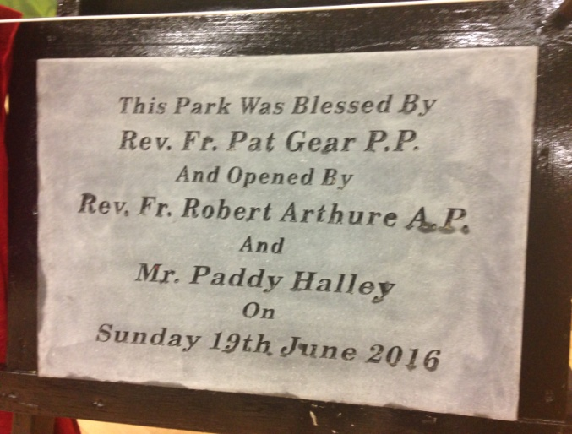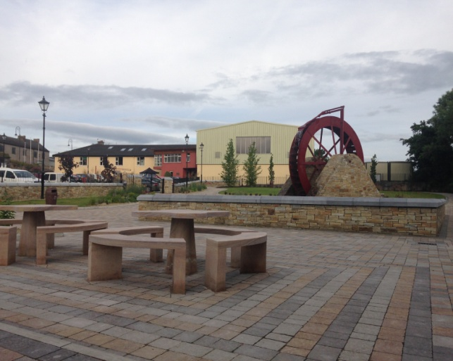

The Company wish to thank Ms Anne McGovern, Ms Christina Johnston and Ms Michelle Woodside for their administrative work during 2016. A new photocopier for the Company office was purchased during the year and some laptops which were surplus to requirements were sold.

The Sean Kelly Tour 50km race again visited the Community Centre in August 2016. We thank our cohort of voluntary people who provided stewarding and prepared food for the participants.

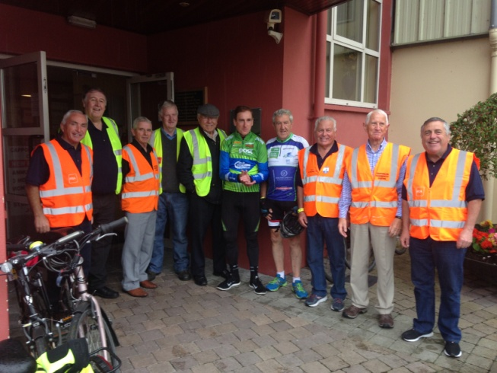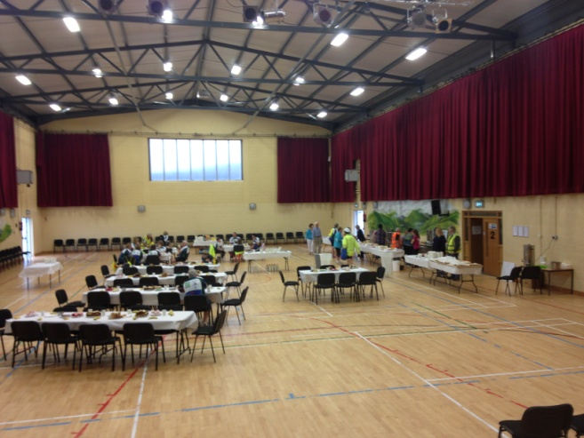

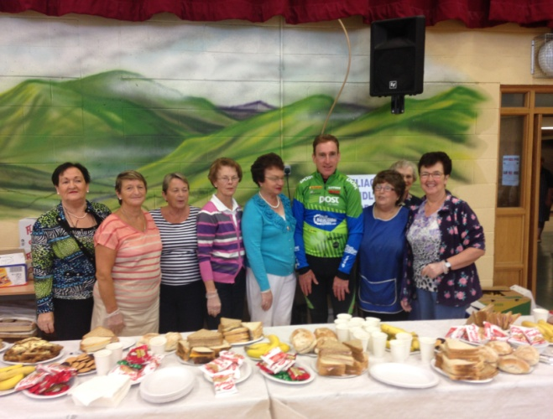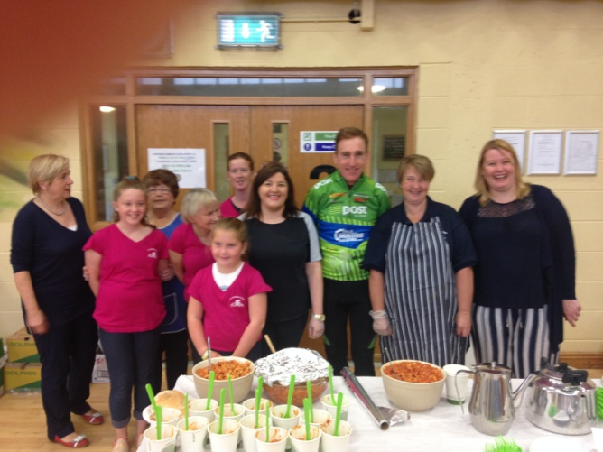

The Company wishes to thank Coillte for the provision of a Christmas tree for the Community Centre grounds.
The assistance and support of Waterford Council staff, particularly Ms Josephine McGrath, Mr Ml Bennett and Mr Paddy Halley is greatly appreciated by the Company. The Company wishes Mr Paddy Halley a long and happy retirement and thank him for his work for the Company over many years. A Christmas dinner was provided for the local council staff to acknowledge their contribution.
The Company acknowledges the continued support of Dr Tom Cavanagh and sincerely thank him for this support and active interest in the affairs of the Company.
The Company notes with thanks the assistance of many state agencies during the year namely Waterford City and County Council, Waterford Leader Partnership, HSE, TUSLA, Dept of Social Protection, Pobal and Waterford County Childcare.
The Company also notes the assistance of Glavin and Ronan, Chartered Accountants and Registered Auditors, Lanigan and Curran Legal Advisers, Nolan Farrell and Goff Legal Advisers, Edward Spratt and Sons Auctioneers and AIB.
The Company also thanks Falconer and Associates Chartered Architects and Planning Consultants, Mr Daniel Leahy Electrician and Mr Shane Barry Plumber for their support during the year.
The Company also acknowledges the general support of Ms Siobhan Murphy Arachas, our insurance broker, for her assistance in processing cover and claims.
The minutes of Governing Body meetings were recorded by Mr Joe White for the 20th successive year and we thank Joe for this important function.
The issue of succession planning is one which continues to exercise the minds of the members of the Governing Body and has been discussed at length at meetings. The Company will have to ensure that the necessary persons with appropriate skill sets and commitment are attracted to ensure the long term viability of the Company and to carry on its mission into the future.
On behalf of all members of the Company I wish to thank our Chairperson Dr Ben Murphy for his stewardship of the Company during 2016 and also acknowledge the contributions of all members to the management of the Company.

Denis McCarthy
Company Secretary

